**PRIOR KNOWLEDGE**

**Supervised and unsupervised learning:**

In Supervised Learning, the machine learns under supervision. It contains a model that is able to predict with the help of a labeled dataset. A labeled dataset is one where you already know the target answer.

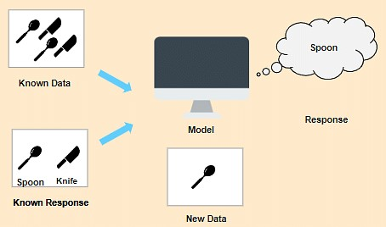

In this case, we have images that are labeled a spoon or a knife. This known data is fed to the machine, which analyzes and learns the association of these images based on its features such as shape, size, sharpness, etc. Now when a new image is fed to the machine without any label, the machine is able to predict accurately that it is a spoon with the help of the past data.

In Unsupervised Learning, the machine uses unlabeled data and learns on itself without any supervision. The machine tries to find a pattern in the unlabeled data and gives a response.

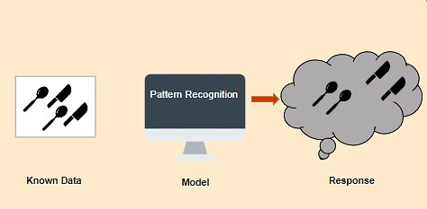

**Classification:**

Classification is used when the output variable is categorical i.e. with 2 or more classes. For example, yes or no, male or female, true or false, etc.

In order to predict whether a mail is spam or not, we need to first teach the machine what a spam mail is. This is done based on a lot of spam filters - reviewing the content of the mail, reviewing the mail header, and then searching if it contains any false information. Certain keywords and blacklist filters that blackmails are used from already blacklisted spammers.

All of these features are used to score the mail and give it a spam score. The lower the total spam score of the email, the more likely that it is not a scam.

**Regression:**

Regression is used when the output variable is a real or continuous value. In this case, there is a relationship between two or more variables i.e., a change in one variable is associated with a change in the other variable. For example, salary based on work experience or weight based on height, etc.

Let’s consider two variables - humidity and temperature. Here, ‘temperature’ is the independent variable and ‘humidity' is the dependent variable. If the temperature increases, then the humidity decreases.  **Clustering:**

Clustering is the method of dividing the objects into clusters that are similar between them and are dissimilar to the objects belonging to another cluster. For example, finding out which customers made similar product purchases.

Suppose a telecom company wants to reduce its customer churn rate by providing personalized call and data plans. The behavior of the customers is studied and the model segments the customers with similar traits. Several strategies are adopted to minimize churn rate and maximize profit through suitable promotions and campaigns.

**Artificial Neural Networks:**

Artificial Neural Networks (ANN) are algorithms based on brain function and are used to model complicated patterns and forecast issues. The Artificial Neural Network (ANN) is a deep learning method that arose from the concept of the human brain Biological Neural Networks. The development of ANN was the result of an attempt to replicate the workings of the human brain. The workings of ANN are extremely similar to those of biological neural networks, although they are not identical. ANN algorithm accepts only numeric and structured data.

Convolutional Neural Networks (CNN) and Recursive Neural Networks (RNN) are used to accept unstructured and non-numeric data forms such as Image, Text, and Speech. This article focuses solely on Artificial Neural Networks.

**Convolutional Neural Networks:**

A convolutional neural network (CNN or ConvNet), is a network architecture for deep learning which learns directly from data, eliminating the need for manual feature extraction.

CNNs are particularly useful for finding patterns in images to recognize objects, faces, and scenes. They can also be quite effective for classifying non-image data such as audio, time series, and signal data.

Applications that call for object recognition and computer vision — such as self-driving vehicles and face-recognition applications — rely heavily on CNNs.

**Flask:**

Flask is a web framework, it’s a Python module that lets you develop web applications easily. It’s having a small and easy-to-extend core: it’s a microframework that doesn’t include an ORM (Object Relational Manager) or such features.

It does have many cool features like url routing, template engine. It is a WSGI web app framework.

Flask is a web application framework written in Python. It was developed by

Armin Ronacher, who led a team of international Python enthusiasts called Poocco. Flask is based on the Werkzeg WSGI toolkit and the Jinja2 template engine.Both are Pocco projects.